Text
Paragraph alignment
The basic need for a binary-to-text encoding comes from a need to communicate arbitrary binary data over preexisting communications protocols that were designed to carry only English language human- readable text. Those communication protocols may only be 7-bit safe (and within that avoid certain ASCII control codes), and may require line breaks at certain maximum intervals, and may not maintain whitespace. Thus, only the 95 printable ASCII characters are "safe" to use to convey data.
Four bytes can represent 232 = 4,294,967,296 possible values. Five radix-85 digits provide 855 = 4,437,053,125 possible values, enough to provide for a unique representation for each possible 32-bit value. Because five radix-84 digits only provide 845 = 4,182,119,424 representable values, 85 is the minimum possible integral base that will represent four bytes in five characters, hence its choice.
When encoding, each group of 4 bytes is taken as a 32-bit binary number, most significant byte first (Ascii85 uses a big-endian convention). This is converted, by repeatedly dividing by 85 and taking the remainder, into 5 radix-85 digits. Then each digit (again, most significant first) is encoded as an ASCII printable character by adding 33 to it, giving the ASCII characters 33 ("!") through 117 ("u").
Because all-zero data is quite common, an exception is made for the sake of data compression, and an all- zero group is encoded as a single character "z" instead of "!!!!!".
Groups of characters that decode to a value greater than 232 − 1 (encoded as "s8W-!") will cause a decoding error, as will "z" characters in the middle of a group. White space between the characters is ignored and may occur anywhere to accommodate line-length limitations.
One disadvantage of Ascii85 is that encoded data may contain escape characters such as backslash and quote, which have special meaning in many programming languages and in some text-based protocols. Other base-85 encodings like Z85 are designed to be safe in source code.[2]
Text styles
word1 word2 word3 word4 word5 word6 word7 word8 word9 word10 word11 word12 word13 word14 word15 word16 word17 word18 word19 word20
Hyperlinks
Ascii85, also called Base85, is a form of binary-to-text encoding developed by Paul E. Rutter for the btoa utility. By using five ASCII characters to represent four bytes of binary data (making the encoded
size ¹⁄₄ larger than the original, assuming eight bits per ASCII character), it is more efficient than uuencode or Base64, which use four characters to represent three bytes of data (¹⁄₃ increase, assuming eight bits per ASCII character).
Its main modern uses are in Adobe's PostScript and Portable Document Format file formats, as well as in the patch encoding for binary files used by Git.[1]
Lists
Bullets
- Between 1947 and 1950 the territories of the princely states were politically integrated into the Indian Union.
- Most were merged into existing provinces; others were organised into new provinces, such as Rajputana, Himachal Pradesh, Madhya Bharat, and Vindhya Pradesh, made up of multiple princely states; a few, including Mysore, Hyderabad, Bhopal, and Bilaspur, became separate provinces.
- The new Constitution of India, which came into force on 26 January 1950, made India a sovereign democratic republic. The new republic was also declared to be a "Union of States".
- The constitution of 1950 distinguished between three main types of states:
- Part A states, which were the former governors' provinces of British India, were ruled by an elected governor and state legislature.
- The nine Part A states were Assam, Bihar, Bombay, Madhya Pradesh (formerly
Central Provinces and Berar), Madras, Orissa, Punjab (formerly East Punjab), Uttar Pradesh (formerly the United Provinces), and West Bengal.
- The eight Part B states were former princely states or groups of princely states, governed
by a rajpramukh, who was usually the ruler of a constituent state, and an elected
legislature. The rajpramukh was appointed by the President of India.
- The Part B states were Hyderabad, Jammu and Kashmir, Madhya Bharat, Mysore, Patiala and East Punjab States Union (PEPSU), Rajasthan, Saurashtra, and Travancore-Cochin.
- The ten Part C states included both the former chief commissioners' provinces and some princely states, and each was governed by a chief commissioner appointed by the President of India.
- The Part C states were Ajmer, Bhopal, Bilaspur, Coorg, Delhi, Himachal Pradesh, Cutch, Manipur, Tripura, and Vindhya Pradesh.
- The only Part D state was the Andaman and Nicobar Islands, which were administered by a lieutenant governor appointed by the central government.
- The Union Territory of Puducherry was created in 1954 comprising the previous French enclaves of Pondichéry, Karaikal, Yanam and Mahé. Andhra State was created on 1 October 1953 from the Telugu-speaking northern districts of Madras State.
- The States Reorganization Act of 1956 reorganized the states based on linguistic lines resulting
in the creation of the new states.
- Andhra Pradesh was created with the merger of Andhra State with the Telugu-speaking districts of Hyderabad State in 1956.
- Mysore State was re-organized with the addition of districts of Bellary and South Canara (excluding Kasaragod taluk) and the Kollegal taluk of Coimbatore district from the Madras State, the districts of Belgaum, Bijapur, North Canara and Dharwad from Bombay State, the Kannada- majority districts of Bidar, Raichur and Gulbarga from Hyderabad State and the province of Coorg…
Numbered list
- Here is the first paragraph with some text. This text was taken from Wikipedia.
- The route starts at the intersection of SR-126 (Main Street) and Gentile Street
- Union Pacific Railroad, as well as the Layton Frontrunner station.
- From here, the route travels east along Gentile Street, almost immediately crossing
- Item e: Here is the first paragraph with some text. This text was taken from Wikipedia.
- Item f: The route starts at the intersection of SR-126 (Main Street) and Gentile Street
- Item g: Union Pacific Railroad, as well as the Layton Frontrunner station.
- Item h: From here, the route travels east along Gentile Street, almost immediately crossing
- Item i: Here is the first paragraph with some text. This text was taken from Wikipedia.
- Item j: The route starts at the intersection of SR-126 (Main Street) and Gentile Street
Lettered list
- Here is the first paragraph with some text. This text was taken from Wikipedia.
- The route starts at the intersection of SR-126 (Main Street) and Gentile Street
- Union Pacific Railroad, as well as the Layton Frontrunner station.
- From here, the route travels east along Gentile Street, almost immediately crossing
- Item e: Here is the first paragraph with some text. This text was taken from Wikipedia.
- Item f: The route starts at the intersection of SR-126 (Main Street) and Gentile Street
- Item g: Union Pacific Railroad, as well as the Layton Frontrunner station.
- Item h: From here, the route travels east along Gentile Street, almost immediately crossing
- Item i: Here is the first paragraph with some text. This text was taken from Wikipedia.
- Item j: The route starts at the intersection of SR-126 (Main Street) and Gentile Street
Images
Floating (inlined) images
The image is in the middle of the text. The image is in the middle of the text. The image is in the middle of the text. The image is in the middle of the text. The image is in the middle of the text. The image is in the middle of the text.
The text follows.
The next image is to the right of the text. The next image is to the right of the text. The next image is to the right of the text. The next image is to the right of the text. The next image is to the right of the text. The next image is to the right of the text. The next image is to the right of the text. The next image is to the right of the text. The next image is to the right of the text. The next image is to the right of the text. The next image is to the right of the text. The next image is to the right of the text. The next image is to the right of the text. The next image is to the right of the text. The next image is to the right of the text. The next image is to the right of the text. The next image is to the right of the text. The next image is to the right of the text. The next image is to the right of the text. The next image is to the right of the text. The next image is to the right of the text. The next image is to the right of the text. The next image is to the right of the text. The next image is to the right of the text. The next image is to the right of the text. The next image is to the right of the text.
The next image is to the left of the text. The next image is to the left of the text. The next image is to the left of the text. The next image is to the left of the text. The next image is to the left of the text. The
next image is to the left of the text. The next image is to the left of the text. The next image is to the left of the text. The next image is to
the left of the text. The next image is to the left of the text. The next image is to the left of the text. The next image is to the left of the
text. The next image is to the left of the text. The next image is to the left of the text. The next image is to the left of the text. The next image is to the left of the text. The next image is to the left of the text. The next
image is to the left of the text. The next image is to the left of the text. The next image is to the left of the text. The next image is to the left of the text. The next image is to the left of the text.
Inline image , Inline image , Inline image , Inline image , Inline image , Inline image , Inline image , Inline image , Inline image , Inline image , Inline image , Inline image , Inline image ,
Inline image , Inline image , Inline image , Inline image , Inline image , Inline image , Inline image , Inline image
Behind Behind Behind Behind Behind Behind Behind Behind Behind Behind Behind Behind Behind Behind Behind Behind Behind Behind Behind Behind Behind Behind Behind Behind Behind Behind Behind Behind Behind Behind Behind Behind Behind Behind Behind Behind Behind Behind Behind Behind Behind Behind Behind Behind Behind Behind Behind Behind Behind Behind Behind Behind
In front In front In front In front In front In front In front In front In front In front In front In front In front In front In front In front In front In front In front In front In front In front In front In front In front In front In front In front In front In front In front In front In front In front In front In front In front In front In front In front In front In front In front In front In front In front In front In front In front In front In front In front In front In front In front In front In front In front In front In front In front In front In front In front In front
Rotated images
Rotation 45 degrees:
Rotation 90 degrees:
Rotation 180 degrees:
Rotation 315 degrees:

Full page image
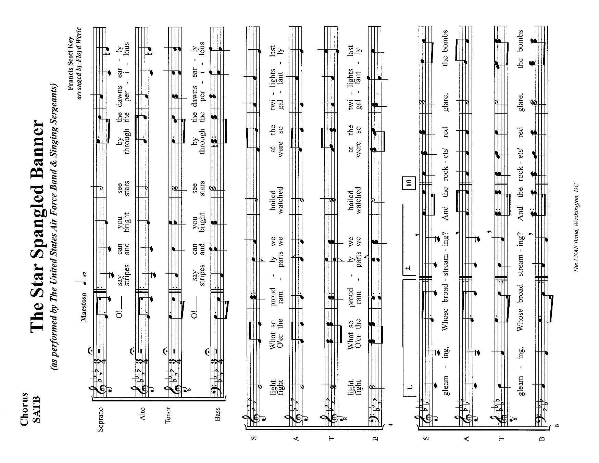
Tables
Normal tables
Table A4-1. Projected U.S. Installed Server Base (in 1000s)
by Server Class and Space Type, Current Efficiency Trends Scenario, 2007 to 2011

Volume servers in: | 2007 | 2008 | 2009 | 2010 | 2011
Server closets | 1,870 | 1,945 | 2,023 | 2,104 | 2,188
Server rooms | 2,400 | 2,660 | 2,925 | 3,213 | 3,642
Localized data centers | 2,060 | 2,283 | 2,510 | 2,757 | 3,126
Mid-tier data centers | 1,860 | 2,062 | 2,267 | 2,490 | 2,823
Enterprise-class data centers | 3,639 | 4,033 | 4,435 | 4,871 | 5,522
Total volume | 11,829 | 12,982 | 14,160 | 15,434 | 17,300
Mid-range servers in: | 2007 | 2008 | 2009 | 2010 | 2011
Server closets | 0 | 0 | 0 | 0 | 0
Server rooms | 17 | 17 | 16 | 16 | 15
Localized data centers | 55 | 53 | 52 | 52 | 48
Mid-tier data centers | 49 | 48 | 47 | 46 | 43
Enterprise-class data centers | 226 | 219 | 214 | 212 | 198
Total mid-range | 347 | 336 | 330 | 326 | 304
High-end servers in: | 2007 | 2008 | 2009 | 2010 | 2011
Server closets | 0 | 0 | 0 | 0 | 0
Server rooms | 0 | 0 | 0 | 0 | 0
Localized data centers | 3 | 3 | 2 | 2 | 2
Mid-tier data centers | 3 | 2 | 2 | 2 | 2
Enterprise-class data centers | 13 | 12 | 11 | 11 | 10
Total high-end | 18 | 17 | 16 | 15 | 15
Table A4-2. Projected U.S. Installed Base of Volume Servers (in 1000s) by Space Type, Historical Trends Scenario, 2007 to 2011

Volume servers in: | 2007 | 2008 | 2009 | 2010 | 2011
Server closets | 1,873 | 1,971 | 2,079 | 2,190 | 2,271
Server rooms | 2,408 | 2,731 | 3,088 | 3,475 | 3,918
Localized data centers | 2,067 | 2,351 | 2,665 | 3,005 | 3,385
Mid-tier data centers | 1,867 | 2,123 | 2,407 | 2,714 | 3,057
Enterprise-class data centers | 3,652 | 4,154 | 4,709 | 5,310 | 5,980
Total volume | 11,866 | 13,330 | 14,949 | 16,693 | 18,611

Table without gridlines

Retained Earnings at beginning of Interim Period | 1,107,231
Increase | 2,426
Effect of the Decrease of Affiliates | 21
Transfer from Revaluation Reserve for Land | 2,404
Decrease | 43,408
Dividends | 43,407
Bonuses to Directors and Corporate Auditors | 0
Net Loss | 264,637
Retained Earnings at end of Interim Period | 801,612
(Notes) Amounts less than one million yen are rounded down.

